**Performance Test Report**

**For**

**Execution of**

**Registration-Processor – 50 users**

Date: 20 Sept 2019

Author: Gaurav Sharan

**Summary**

This report presents the observations and findings of the load test conducted for a load of 50 users accessing registration processor APIs over a time of 60 minutes.

Below are the scenario details:

|  |  |
| --- | --- |
| **Script/Report Name** | Registration Processor sync and packet upload |
| **Run Date** | 19-Sept-2019 |
| **Period** | 19:19 UTC to 10:23 UTC |
| **Number of concurrent users** | 100 : 50 was achieved |
| **Ramp up** | 6 users per 60 seconds |
| **Run Duration** | 60 minutes |
| **Ramp down** | NA |

The transaction response times observed were as below:

|  |  |  |  |  |  |  |  |
| --- | --- | --- | --- | --- | --- | --- | --- |
| **Label** | **# Samples** | **Average(ms)** | **90% Line(ms)** | **Min(ms)** | **Max(ms)** | **Error %** | **Throughput** |
| **TR_regproc_authentication** | 2009 | 259 | 390 | 105 | 8590 | 0.00% | 0.50298 |
| **TR_regproc_encrypt** | 2003 | 22 | 20 | 8 | 5331 | 0.00% | 0.50303 |
| **TR_regproc_sync_reg_packets** | 1998 | **21950** | **26150** | 1381 | 49522 | 0.20% | 0.50347 |
| **TR_regproc_upload_registration_packet** | 1984 | **23311** | **29936** | 1354 | 56855 | 0.20% | 0.50148 |
| **TR_regproc_check_packet_upload_status** | 1965 | 315 | 288 | 116 | 14746 | 0.00% | 0.49801 |

**Performance Test Execution Details**

We have executed JMeter script for registration-processor sync, packet upload and packet status, which has transactions mentioned in the above table.

Average response time of sync request and packet upload are above 15 seconds.

**Test Environment**



**Response Time Graph:**

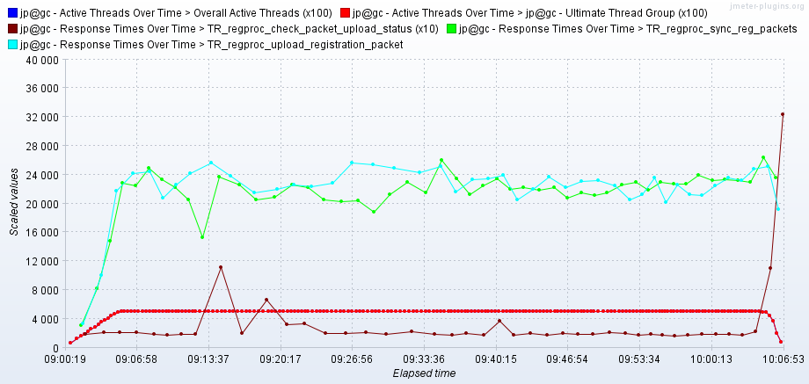

**Transactions per second**:

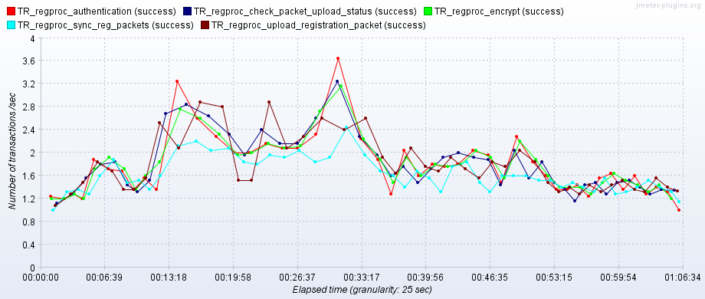

**Some Error Responses:**

Erroneous responses of the transactions having failure rate below 1% are given below for further debugging.

**TR_regproc_upload_packet:**

**{"errors":[{"errorCode":"RPR-PKR-007","message":"Unknown Exception Found"}],"id":"mosip.registration.packet","version":"1.0","responsetime":"2019-09-19T08:26:36.025Z"}**

**TR_regproc_sync_packet**

**<p>Sorry, the page you are looking for is currently unavailable.<br/>**

**Please try again later.</p>**

**<p>If you are the system administrator of this resource then you should check**

**the error log for details.</p>**

**<p><em>Faithfully yours, nginx.</em></p>**

**TR_regproc_upload_packet**

**<p>Sorry, the page you are looking for is currently unavailable.<br/>**

**Please try again later.</p>**

**<p>If you are the system administrator of this resource then you should check**

**the error log for details.</p>**

**<p><em>Faithfully yours, nginx.</em></p>**

**Conclusion and Next Steps**

We will repeat the test for 100 users and observe the behavior once developer confirms the issue is fixed. The erroneous responses obtained during the load test will be shared with the developer team for further analysis.